17.- $y=4x-x^{2}, y=0, x=1, x=3$
$$A=\int_{1}^{3}{(4x-x^{2})}dx$$
$$A={\left.(\frac{{4x}^{2}}{2}-\frac{x^{3}}{3})\right|}_{1}^{3}$$
$$A=\left(\frac{{4(3)}^{2}}{2}-\frac{{(3)}^{3}}{3}\right)-\left(\frac{{4(1)}^{2}}{2}-\frac{{(1)}^{3}}{3}\right)$$
$$A=\left(18-9\right)-\left(2-\frac{1}{3}\right)$$
$$A=9-\left(\frac{6-1}{3}\right)$$
$$A=9-\frac{5}{3}$$
$$A=\frac{27-5}{3}$$
$$A=\frac{22}{3}u^{2}$$

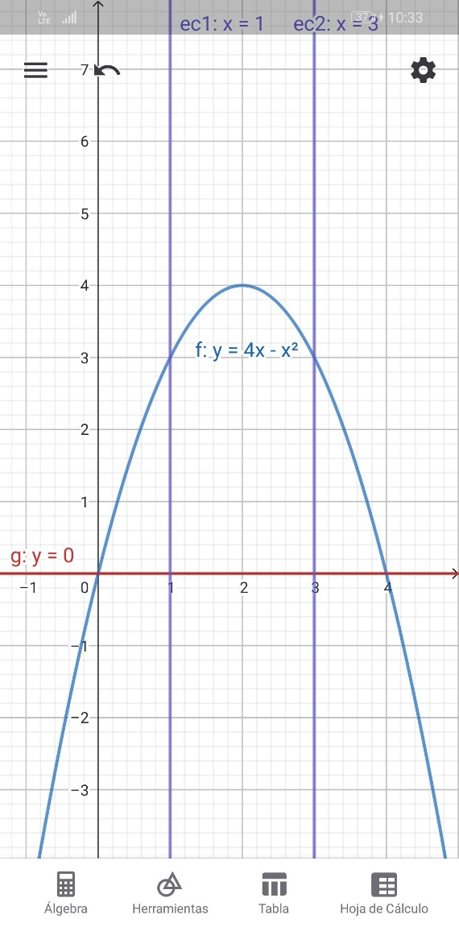

18.- $x=1+y^{2}, x=10$
$$x=10→10=1+y^{2}⇒9=y^{2}⇒\sqrt{9}=y⇒y=±3$$
$$A=\int_{-3}^{3}{(9-y^{2})}dy$$
$$A={\left.(9y-\frac{y^{3}}{3})\right|}_{-3}^{3}$$
$$A=\left(9(3)-\frac{{(3)}^{3}}{3}\right)-\left(9(-3)-\frac{{(-3)}^{3}}{3}\right)$$
$$A=\left(27-9\right)-\left(-27-(-9)\right)$$
$$A=18-\left(-18\right)$$
$$A=36u^{2}$$
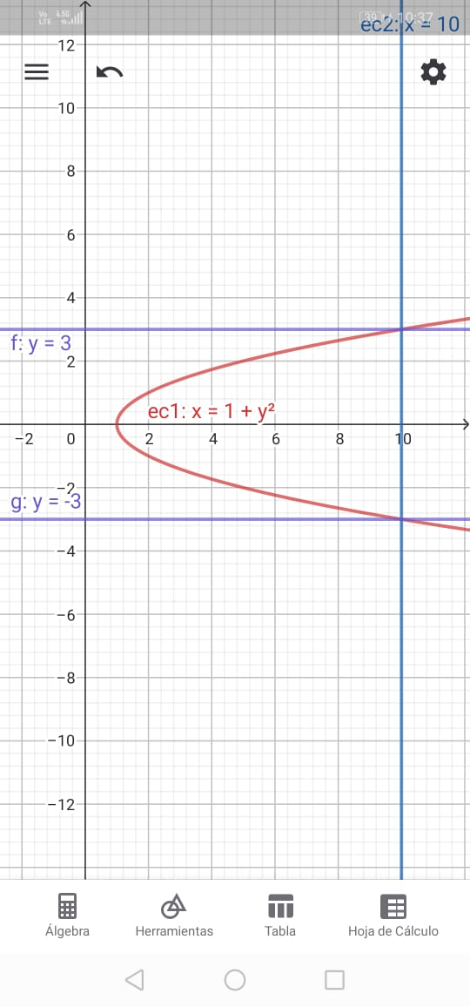

19.- $x=y^{2}+4y, x=0$
$$A=\int_{-4}^{0}{(0-(y^{2}+4y))}dy$$
$$A=\int_{-4}^{0}{(-y^{2}-4y)}dy$$
$$A={\left.(\frac{-y^{3}}{3}-\frac{4y^{2}}{2})\right|}_{-4}^{0}$$
$$A=\left(\frac{{-(0)}^{3}}{3}-\frac{{4(0)}^{2}}{2}\right)-\left(\frac{{-(-4)}^{3}}{3}-\frac{{4(-4)}^{2}}{2}\right)$$
$$A=0-\left(\frac{64}{3}-2(16)\right)$$
$$A=0-\left(\frac{64}{3}-32\right)$$
$$A=0-\left(\frac{64-96}{3}\right)$$
$$A=0-\left(\frac{-32}{3}\right)$$
$$A=\frac{32}{3}u^{2}$$
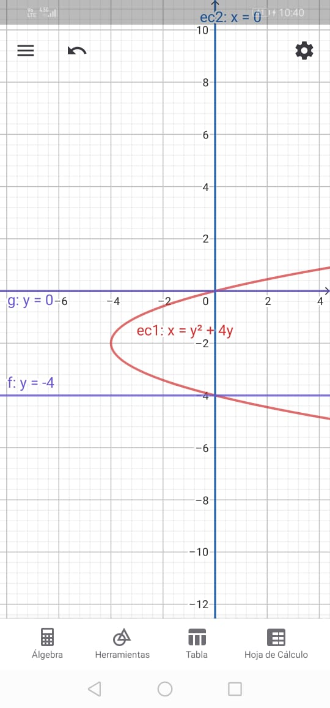

20.- Un sector circular de radio r y ángulo a.
$$A=\int_{θ}^{θ_{2}}{\frac{1}{2}{\left[r(θ)\right]}^{2}}dθ$$
$$A=\int_{0}^{a}{\frac{1}{2}r^{2}}dθ$$
$$A=\frac{1}{2}\int_{0}^{a}{r^{2}}dθ$$
$$A=\frac{1}{2}r^{2}\int_{0}^{a}{ }dθ$$
$$A=\frac{1}{2}r^{2}{\left.\left[θ\right]\right|}_{-4}^{0}$$
$$A=\frac{1}{2}r^{2}(a-0)$$
$$A=\frac{1}{2}r^{2}a$$
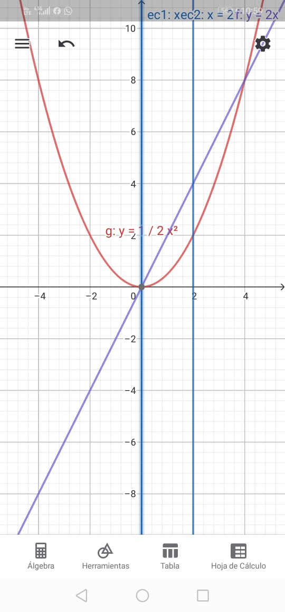

21.- Dentro de $y=25-x^{2}, 256x=3y^{2},16y=9x^{2}$
$$16y=9x^{2}→y=\frac{9}{16}x^{2}$$
$$25-x^{2}=\frac{9}{16}x^{2}$$
$$25=\frac{9x^{2}}{16}+x^{2}$$
$$25=x^{2}\left(1+\frac{9}{16}\right)$$
$$x^{2}=25\left(\frac{9}{25}\right)$$
$$x^{2}=16$$
$$x=\sqrt{16}$$
$$x=±4$$
$$A=2\int_{0}^{4}{(\left(25-x^{2}\right)-(\frac{9}{16}x^{2}))}dx$$
$$A=2\int_{0}^{4}{\left(25-\frac{25 x^{2}}{16}\right)}dx$$
$$A={2\left.(25x-\frac{25 x^{3}}{48})\right|}_{0}^{4}$$
$$A=2(25\left(4\right)-\frac{25{\left(4\right)}^{3}}{48}-0)$$
$$A=2(100-25\frac{4}{3})$$
$$A=2(100-\frac{100}{3})$$
$$A=2(\frac{200}{3})$$
$$A=\frac{400}{3}u^{2}$$
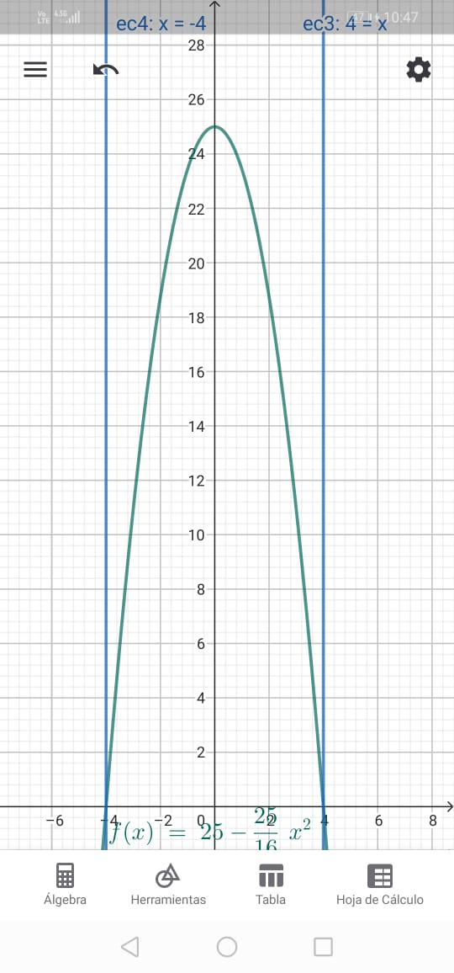
22.- $y=x^{4}-4x^{2}, y=4x^{2}$
$$x^{4}-4x^{2}=4x^{2}$$
$$x^{4}-4x^{2}-4x^{2}=0$$
$$x^{4}-8x^{2}=0$$
$$x^{2}=0, x=0, x^{2}=8$$
$$x=\sqrt{8}$$
$$x=±2\sqrt{2}$$
$$A=2\int_{0}^{2\sqrt{2}}{(4x^{2}-\left(x^{2}-4x^{2}\right))}dx$$
$$A=2\int_{0}^{2\sqrt{2}}{(8x^{2}-x^{4})}dx$$
$$A={2\left.(\frac{8x^{3}}{3}-\frac{ x^{5}}{5})\right|}_{0}^{2\sqrt{2}}$$
$$A=2\left[\frac{8{(2\sqrt{2})}^{3}}{3}-\frac{ {\left(2\sqrt{2}\right)}^{5}}{5}-0\right]$$
$$A=2\left[\frac{8(16\sqrt{2})}{3}-\frac{128\sqrt{2}}{5}\right]$$
$$A=2\left[\frac{128\sqrt{2}}{3}-\frac{128\sqrt{2}}{5}\right]$$
$$A=2\left[\frac{640\sqrt{2}-384\sqrt{2}}{15}\right]$$
$$A=2\left[\frac{(640-384)\sqrt{2}}{15}\right]$$
$$A=2\left[\frac{256\sqrt{2}}{15}\right]$$
$$A=\frac{512\sqrt{2}}{15}u^{2}$$
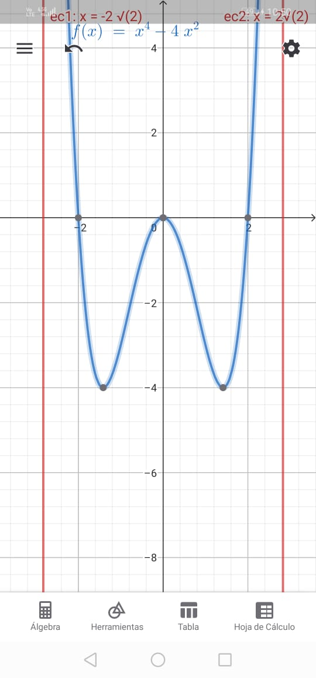
23.- $y=e^{\frac{x}{a}}+e^{-\frac{x}{a}}, y=0,x=±a$
$$A=2\int_{0}^{a}{(e^{\frac{x}{a}}+e^{-\frac{x}{a}})}dx→u=\frac{x}{a}⇒du=\frac{1}{a}dx⇒dx=dua$$
$$A={2\left.({\frac{1}{\frac{1}{a}}e}^{\frac{x}{a}}+{\frac{1}{-\frac{1}{a}}e}^{-\frac{x}{a}})\right|}_{0}^{a}$$
$$A={2\left.({ae}^{\frac{x}{a}}-{ae}^{-\frac{x}{a}})\right|}_{0}^{a}$$
$$A={2a\left.(e^{\frac{x}{a}}-e^{-\frac{x}{a}})\right|}_{0}^{a}$$
$$A=2a\left[e^{\frac{a}{a}}-e^{-\frac{a}{a}}-0\right]$$
$$A=2a\left[e^{1}-e^{-1}\right]u^{2}$$
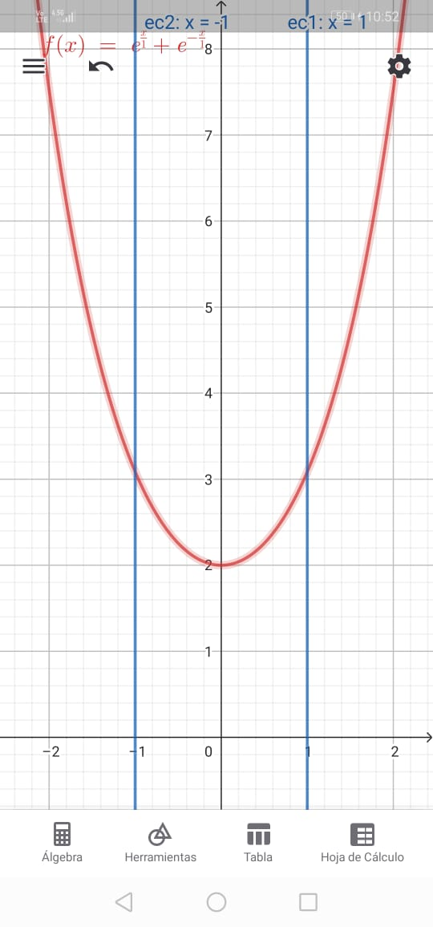

24.- $y=\frac{1}{(1+x^{2})}, y=0,x=±1$
$$A=2\int_{0}^{1}{\left(\frac{1}{1+x^{2}}\right)}dx$$
$$A={2\left.\left[arctan⁡(x)\right]\right|}_{0}^{1}$$
$$A=2\left[\arctan\left(1\right)-\arctan\left(0\right)\right]$$
$$A=2\left[\frac{π}{4}-0\right]$$
$$A=\frac{2π}{4}$$
$$A=\frac{π}{2}u^{2}$$
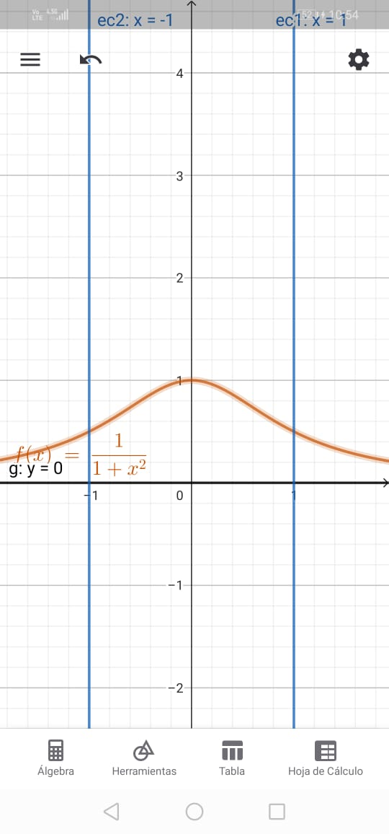
25.- Encontrar el área comprendida entre las curvas y=$x^{2};y=x^{3}$
$$x^{2}=x^{3}$$
$$x^{2}(1-x)=0$$
$$x=0, x=1$$
$$A=\int_{0}^{1}{\left(x^{2}-x^{3}\right)}dx$$
$$A={\left.\left(\frac{x^{3}}{3}-\frac{x^{4}}{4}\right)\right|}_{0}^{1}$$
$$A=\frac{{(1)}^{3}}{3}-\frac{{\left(1\right)}^{4}}{4}-0$$
$$A=\frac{1}{3}-\frac{1}{4}$$
$$A=\frac{1}{12}u^{2}$$
